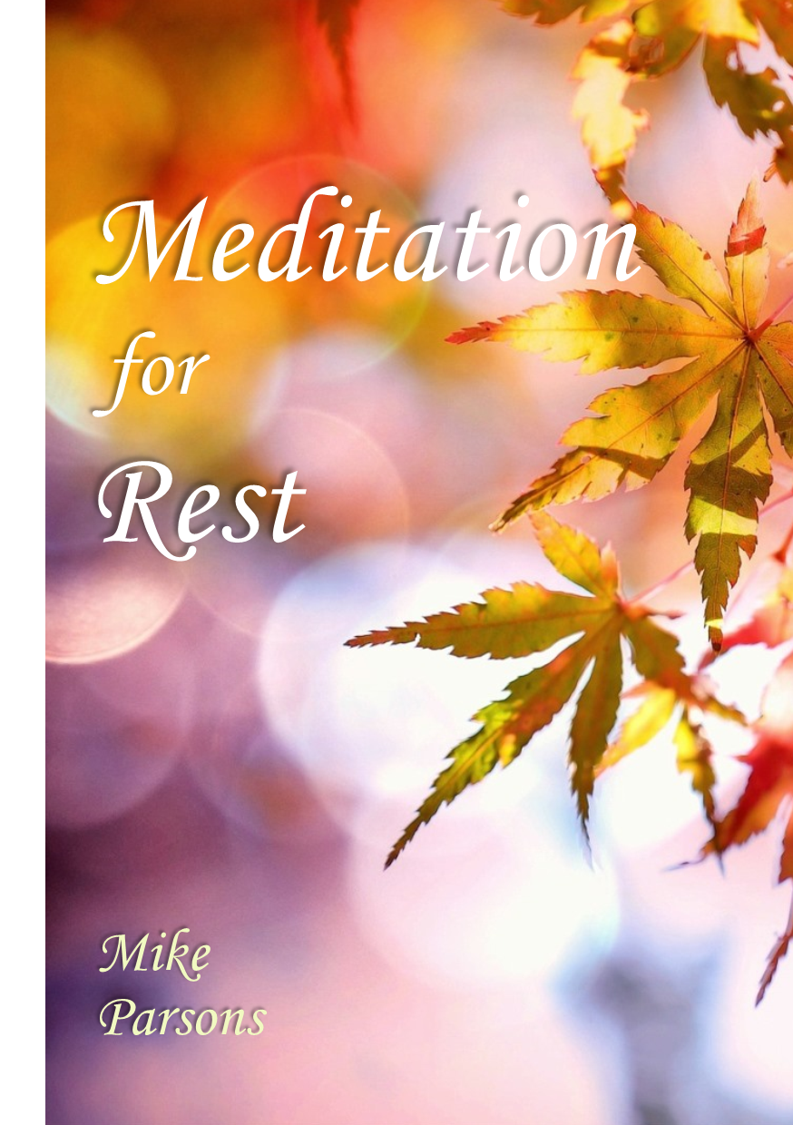

©2018 Freedom Apostolic Ministries Ltd., a not-for-profit company registered in England.
Company number 10359676. Registered office: Freedom Centre, 1 Howard Avenue, Barnstaple EX32 8QA, UK. All rights reserved.
Daily Meditation for Rest

In this booklet we introduce the first 3 steps and step 7 of Mike’s 7-step daily meditation for rest. You can add the remaining steps (and/or others) as you engage with God and get revelation on them.
1. Love – feeling compassion
2. Joy – feeling thankful and grateful
3. Peace – Forgiveness and blessing
4. Surrender – Being a living sacrifice
5. Engaging destiny – having clear vision
6. Framing life – creating reality
7. Living in blessing and empowerment

Preparation
Close your eyes, think about and focus on your breathing and begin to slow it down to the rhythm ‘YOD - HEI - VAV - HEI’.
Breathe in deeply the breath of God and exhale slowly ‘YOD’.
Breathe in deeply ’HEI’ and exhale slowly ‘VAV’.
Breathe in deeply ‘HEI’. Repeat ‘YOD - HEI - VAV - HEI’.
Focus on breathing slowly. Be still and rest. Listen to God’s voice:
“Be still and know that I am God (Psa 46:10).
Be still and know that I am love.
Be still and know that I am joy.
Be still and know that I am peace.”
1. First Love - Living Loved

Keep breathing slowly and focus your thoughts on God who is love. Think of being loved, cared for, accepted and affirmed by your loving heavenly Father. Feel God’s love compassion and comfort for you.
Behold, I stand at the door and knock; if anyone hears My voice and opens the door, I will come in to him and will dine with him, and he with Me
(Rev 3:20).
Focus your thoughts on the door within you and picture it.
Choose to open that door and invite Father, Son and Spirit into your spirit.
A river of love begins to flow. Be immersed in the Spirit’s love.
Jesus and the Father hug you, putting their arms around you, and you start to sink deeper into love’s embrace.
You begin to feel cocooned, safe, resting in God’s arms of love.
Feel love’s warmth flowing into your spirit. Feel love flowing deeper and deeper, filling your spirit with love’s very essence.
You feel filled to overflowing with love.
Drink in that life-giving stream, the Spirit of pure love.
Choose to take Jesus’ yoke on your shoulders and feel joined to Him as a son and co-heir, at rest.
Now choose to surrender the control of your life to the Father.
Feel love like a river flow out through your spirit into your soul.
Feel that love begin to saturate your soul, filling your emotions, mind and will.
Choose to surrender to love and begin to feel totally at rest.
As you feel love, relax and begin to feel love flow through your body, bringing it into rest.
Feel love flow over your body from your head, flowing down your neck and shoulders to your chest, all the way to the tip of your toes.
Now intentionally release that love like a flowing river through you
creating an atmosphere of love around you.
Direct the flow of love out to the different areas of your life: family, community, friends, neighbours, ekklesia, to the world.
Love is flowing like a river from your innermost being, creating an atmosphere of love that overshadows your life.
You are in a state of bliss, living loved.
You are resting in a deep sense of being loved.

2. Joy, Gratitude, Thankfulness – Loving Living

Continue to relax and begin to think of someone or something you are thankful for.
Release your gratitude.
Think of someone who has been kind to you or blessed you.
Be grateful you are alive.
Thank God for His love, thank Jesus for dying for you etc.
Feel joy fill you and saturate you.
Feel that joy filling your soul.
Feel that joy flowing over your body from your head to your toes.
Release your gratitude as a flow of joy from the inside out.
Fill the atmosphere around you with joy.
3. Peace, Forgiveness – Living Loving

Focus on Jesus’ words:
Peace I leave with you; My peace I give to you; not as the world gives do I give to you. Do not let your heart be troubled, nor let it be fearful (John 14:27).
Think of anyone or anything that has disturbed you, frustrated you, annoyed you, upset you or hurt you.
Picture them and consciously choose to forgive and release them.
Visualise that person and say to them “I forgive and release you and bless you”.
Hear them say “I receive your forgiveness”.
Repeat if necessary.
Now think of anyone you may have hurt, upset or annoyed, and ask them to forgive you.
Hear them say “I forgive, release and bless you”.
Feel peace filling you, taking you deeper into rest.
Feel the peace flow slowly over your body from your head to your toes.
Release forgiveness like a flowing river out into the world.
Create an atmosphere of forgiveness around you.

7. Blessing and empowerment

Hear the Father’s words of affirmation: “You are my beloved son [or daughter] in whom I am well pleased and in whom my soul delights.”
Step into YHVH; step into the Lion, Ox, Eagle, Man.
Feel the pleasure of the Father’s heart for you and for destiny today
Hear the Father say “I bless you, My son [daughter], to be fruitful today.
I empower you to prosper and succeed today; to increase, overcome and rule.”
Feel the light of love energising you.
Feel the energy and power of God’s presence pulsating within you.
You are in YHVH and YHVH is in you.
Your identity and position is of the heavenly order of Melchizedek.
You are joined to the Lord and one spirit with Him.
You are a house of God and a gateway of heaven into the earth.
Feel and sense the abundance of life within you.
Be at rest, fulfilled and contented, being filled with love, joy and peace.
Release the flow of abundant life as a river flowing from your innermost being into the world around you.
***
We begin with YHVH in us and we end with being in YHVH: the cycle where the beginning and the end meet in fruitfulness and recovery.
When we step into the name of YHVH we are royal priests of the order of Melchizedek and we live in the power of His name.

