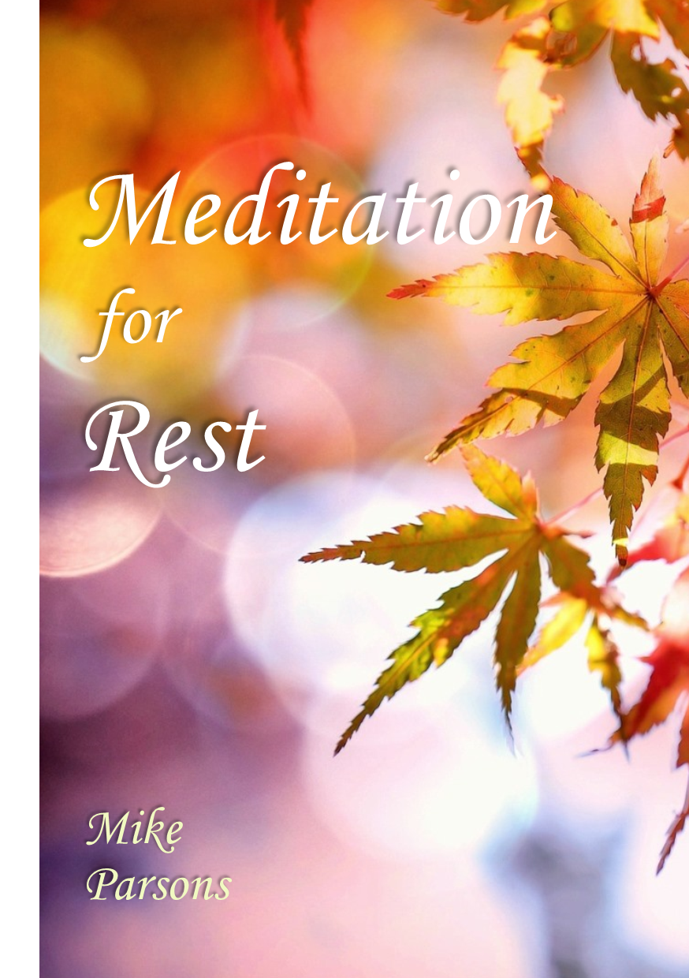

©2018 Freedom Apostolic Ministries Ltd., a not-for-profit company registered in England.
Company number 10359676. Registered office: Freedom Centre, 1 Howard Avenue, Barnstaple EX32 8QA, UK. All rights reserved.
7 Step Daily Meditation for Rest

1. Love – feeling compassion
2. Joy – feeling thankful and grateful
3. Peace – Forgiveness and blessing
4. Surrender – Being living sacrifices
5. Engaging destiny – having clear vision
6. Framing life – creating reality
7. Living in blessing and empowerment

Preparation
Close your eyes, think about and focus on your breathing and begin to slow it down to the rhythm ‘YOD - HEI - VAV - HEI’.
Breathe in deeply the breath of God and exhale slowly ‘YOD’.
Breathe in deeply ’HEI’ and exhale slowly ‘VAV’.
Breathe in deeply ‘HEI’. Repeat ‘YOD - HEI - VAV - HEI’.
Focus on breathing slowly. Be still and rest. Listen to God’s voice:
“Be still and know that I am God (Psa 46:10).
Be still and know that I am love.
Be still and know that I am joy.
Be still and know that I am peace.”

1. First Love - Living Loved

Keep breathing slowly and focus your thoughts on God who is love. Think of being loved, cared for, accepted and affirmed by your loving heavenly Father. Feel God’s love compassion and comfort for you.
Behold, I stand at the door and knock; if anyone hears My voice and opens the door, I will come in to him and will dine with him, and he with Me
(Rev 3:20).
Focus your thoughts on the door within you and picture it.
Choose to open that door and invite Father, Son and Spirit into your spirit.
A river of love begins to flow. Be immersed in the Spirit’s love.
Jesus and the Father hug you, putting their arms around you, and you start to sink deeper into love’s embrace.
You begin to feel cocooned, safe, resting in God’s arms of love.
Feel love’s warmth flowing into your spirit. Feel love flowing deeper and deeper, filling your spirit with love’s very essence.
You feel filled to overflowing with love.
Drink in that life-giving stream, the Spirit of pure love.
Choose to take Jesus’ yoke on your shoulders and feel joined to Him as a son and co-heir, at rest.
Now choose to surrender the control of your life to the Father.
Feel love like a river flow out through your spirit into your soul.
Feel that love begin to saturate your soul, filling your emotions, mind and will.
Choose to surrender to love and begin to feel totally at rest.
As you feel love, relax and begin to feel love flow through your body, bringing it into rest.
Feel love flow over your body from your head, flowing down your neck and shoulders to your chest, all the way to the tip of your toes.
Now intentionally release that love like a flowing river through you
creating an atmosphere of love around you.
Direct the flow of love out to the different areas of your life: family, community, friends, neighbours, ekklesia, to the world.
Love is flowing like a river from your innermost being, creating an atmosphere of love that overshadows your life.
You are in a state of bliss, living loved.
You are resting in a deep sense of being loved.

2. Joy, Gratitude, Thankfulness – Loving Living

Continue to relax and begin to think of someone or something you are thankful for.
Release your gratitude.
Think of someone who has been kind to you or blessed you.
Be grateful you are alive.
Thank God for His love, thank Jesus for dying for you etc.
Feel joy fill you and saturate you.
Feel that joy filling your soul.
Feel that joy flowing over your body from your head to your toes.
Release your gratitude as a flow of joy from the inside out.
Fill the atmosphere around you with joy.
3. Peace, Forgiveness – Living Loving

Focus on Jesus’ words:
Peace I leave with you; My peace I give to you; not as the world gives do I give to you. Do not let your heart be troubled, nor let it be fearful (John 14:27).
Think of anyone or anything that has disturbed you, frustrated you, annoyed you, upset you or hurt you.
Picture them and consciously choose to forgive and release them.
Visualise that person and say to them “I forgive and release you and bless you”.
Hear them say “I receive your forgiveness”.
Repeat if necessary.
Now think of anyone you may have hurt, upset or annoyed, and ask them to forgive you.
Hear them say “I forgive, release and bless you”.
Feel peace filling you, taking you deeper into rest.
Feel the peace flow slowly over your body from your head to your toes.
Release forgiveness like a flowing river out into the world.
Create an atmosphere of forgiveness around you.

4. Surrender – Living Sacrifices

Start to think about Romans 12:1.
Therefore I urge you, brethren, by the mercies of God, to present your bodies a living and holy sacrifice, acceptable to God, which is your spiritual service of worship.
Feeling at rest, safe and secure, choose to surrender your free will to God’s will.
Choose to surrender to recovery.
Choose to present yourself as a living sacrifice to the Father.
See yourself lying on the altar.
Start to think about Psalm 139:1.
O Lord, You have searched me and known me.
Sense God’s amazing, loving desire for you, knowing everything about you and wanting the best for you, for you to be whole.
Start to think about Psalm 139:16-17.
Your eyes have seen my unformed substance;
and in Your book were all written the days that were ordained for me, when as yet there was not one of them.
How precious also are Your thoughts to me, O God!
How vast is the sum of them!
His amazing thoughts about you start to flow around your mind,
His truth beginning to penetrate any strongholds and lies,
His thoughts beginning to change and align your thoughts to His thoughts.
Knowing that you are loved and accepted, start to think about Psalm 139:23-24.
Search me, O God, and know my heart;
Try me and know my anxious thoughts;
and see if there be any hurtful way in me,
and lead me in the everlasting way.
Ask the Father to search your heart and reveal any anxious thoughts or iniquitous ways.
Ask the Father to deal with anything that will hinder you fulfilling your destiny or recovery today.
Ask the Father to reveal the desires of His heart to you.
Think about Rom 12:2.
And do not be conformed to this world, but be transformed by the renewing of your mind, so that you may prove what the will of God is, that which is good and acceptable and perfect.
Turn your heart towards seeking first the kingdom of God.
Tell the Father that you only want to do what you see Him doing.
Allow the Father to transform you by renewing your mind and conforming you to sonship.

5. Engaging Your Destiny – Resting in surrender with love, joy and peace.

Focus your thinking on your day and receive a scroll with your destiny for today - to recover.
Think of today as an opportunity and a pleasure.
Think of your day and think about it in love, joy and peace.
Today you live loved. Today you love living. Life brings you joy.
Today you live loving, at peace and in forgiveness.
Think of your scroll. Sense any specific mandates for what the Father is doing in you, around you and through you today.
Choose to place it in your heart.
Choose only to do what you see the Father doing.
His will is nourishment to your soul. Feel His strength fill you.
Think about your day and rest.
Choose to accept your destiny.
Relax and feel the joy and pleasure of the Father’s heart.
Your destiny today is filled with love, joy and peace - recovery.
Look at your day from rest.
Feel desire rise in your heart, overflowing with love, joy and peace, bringing fulfilment in rest.
Visualise being blessed to be fruitful, successful and fulfilled at home, community, at work and in recovery.
Everywhere you go, grace and mercy go before you.
6. Framing your life in peace

Think of what you will be doing today and think of being successful.
See the possibilities for you to be fruitful today and choose that reality to manifest around you today.
…and raised us up with Him, and seated us with Him in the heavenly places in Christ Jesus (Eph 2:6).
Focus on the scroll and desire in your heart and think about sitting at rest on your mountain throne.
Feel the love, joy and peace.
Let the desires of the Father’s heart for you fill you with passion and excitement for your day.
Begin to frame your day from the desire of your scroll and the reality you have chosen with the favour and blessing of God: declare success; call for the alignment of heaven and earth
Think about your day.
Begin to see what you need and see the reality of blessing.
Call forth the provision for today.
Declare that you have all that you need to fulfil all that you are called to do today.
Call forth connections with the angelic realm and the cloud of witnesses.
Release out into creation the sound and frequency of rest that will attract fruitfulness.
Feel peace and contentment rise up in your heart.
Release that peace like a river into the atmosphere around you.

7. Blessing and empowerment

Hear the Father’s words of affirmation: “You are my beloved son [or daughter] in whom I am well pleased and in whom my soul delights.”
Step into YHVH; step into the Lion, Ox, Eagle, Man.
Feel the pleasure of the Father’s heart for you and for destiny today
Hear the Father say “I bless you, My son [daughter], to be fruitful today.
I empower you to prosper and succeed today; to increase, overcome and rule.”
Feel the light of love energising you.
Feel the energy and power of God’s presence pulsating within you.
You are in YHVH and YHVH is in you.
Your identity and position is of the heavenly order of Melchizedek.
You are joined to the Lord and one spirit with Him.
You are a house of God and a gateway of heaven into the earth.
Feel and sense the abundance of life within you.
Be at rest, fulfilled and contented, being filled with love, joy and peace.
Release the flow of abundant life as a river flowing from your innermost being into the world around you.
***
We begin with YHVH in us and we end with being in YHVH: the cycle where the beginning and the end meet in fruitfulness and recovery.
When we step into the name of YHVH we are royal priests of the order of Melchizedek and we live in the power of His name.

